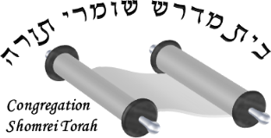

Shul Mailing Address

MailingAddress

Kinds enclosed